Theme 1: Topic 2 – The Market
    - - Demand
Which factors affect demand?

    - - Supply
Which factors affect supply?

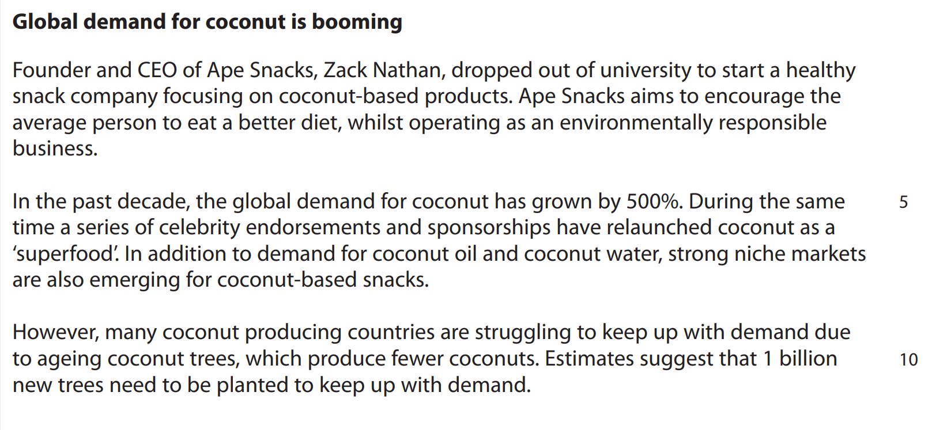

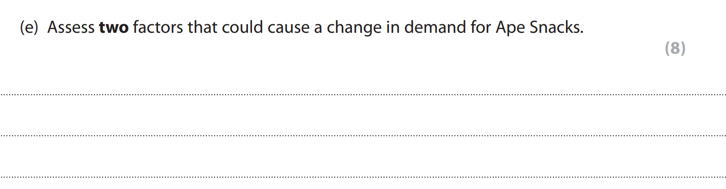

    - - Markets
Movements
What is equilibrium price?
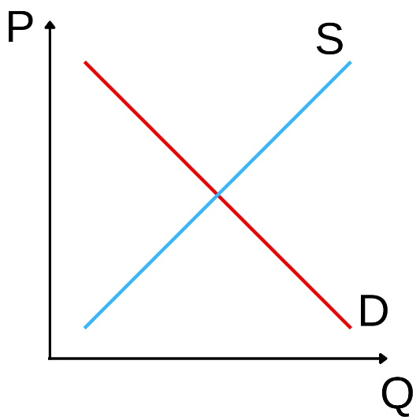
What is a surplus?
What is a shortage?

Shifts
What happens to the supply and demand curves when there is:
- A rise in demand?
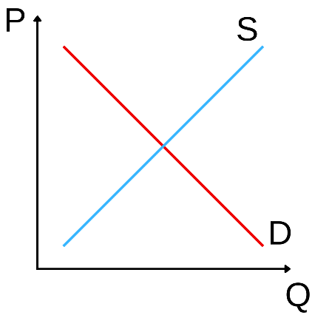

- A fall in demand?

- A rise in supply?

- A fall in supply?

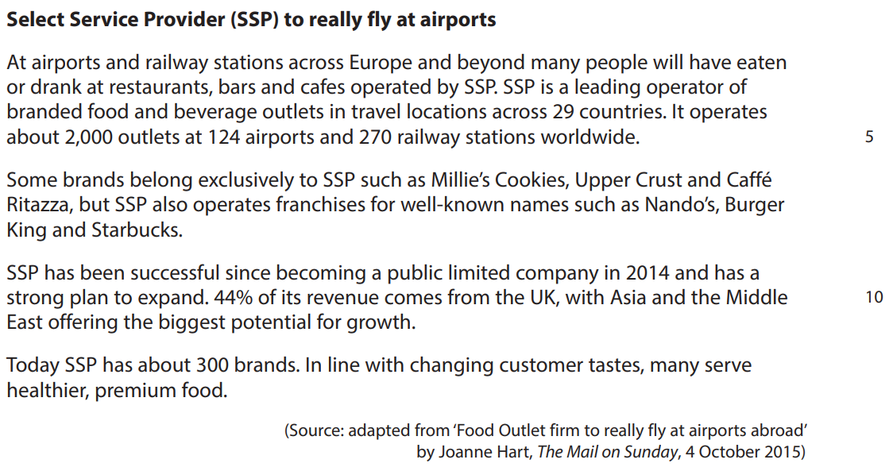

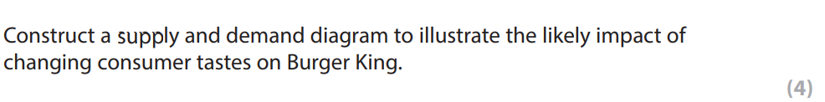

    - - Price elasticity of demand (PED)
What does PED show?

What is the formula for PED?

Calculate PED when a price rise of 20% results in a 30% reduction in demand.

Calculate PED when a price rise of 20% results in a 10% reduction in demand.

Which factors affect price elasticity?

How might the price elasticity of demand of a product affect the sales revenue when the price is raised?

Birdz Ltd sell 100 birdcages per year for £10 each, generating a revenue of £1000.
If PED is -2.5 and Birdz Ltd increases the price by 10%, what is the new sales revenue?

Price elasticity affects businesses’ pricing strategies. How might a business selling a price elastic product set its prices?

Draw demand curves for a price elastic product and a price inelastic product.
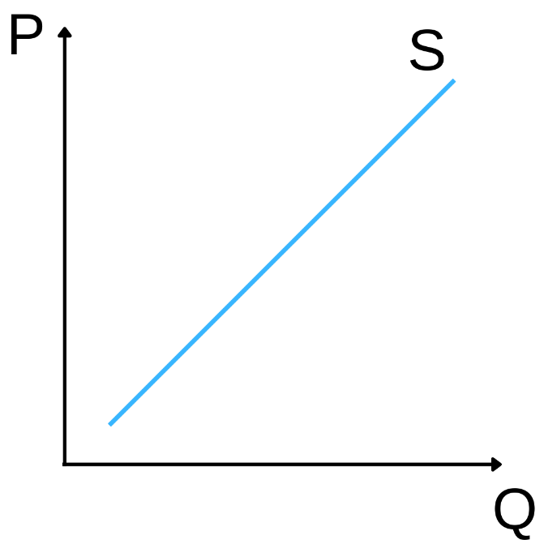

    - - Income elasticity of demand (YED)
What does YED show?

What is the formula?

A 20% rise in income results in a 5% increase in demand. Calculate the YED.

A 15% fall in income results in a 10% increase in demand. Calculate the YED.

Describe the difference in income elasticity of demand of a normal product (a necessity or luxury) compared with an inferior product.

