Theme 1: Topic 2 – The Market
    - - Demand
Which factors affect demand?
- Availability of substitutes
- Availability of complementary products
- Consumer income
- Trends/fashions
- Advertising
- Seasonal changes
- Demographic changes
- External shocks

    - - Supply
Which factors affect supply?
- Cost of production
- Indirect taxes
- Subsidies
- New technology
- Weather conditions
- External shocks

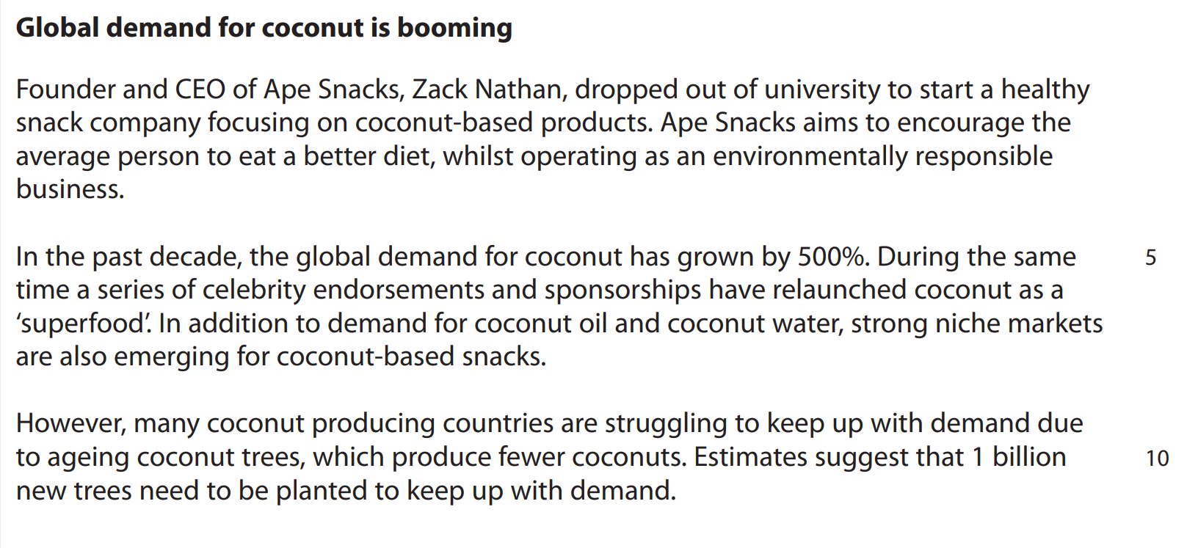

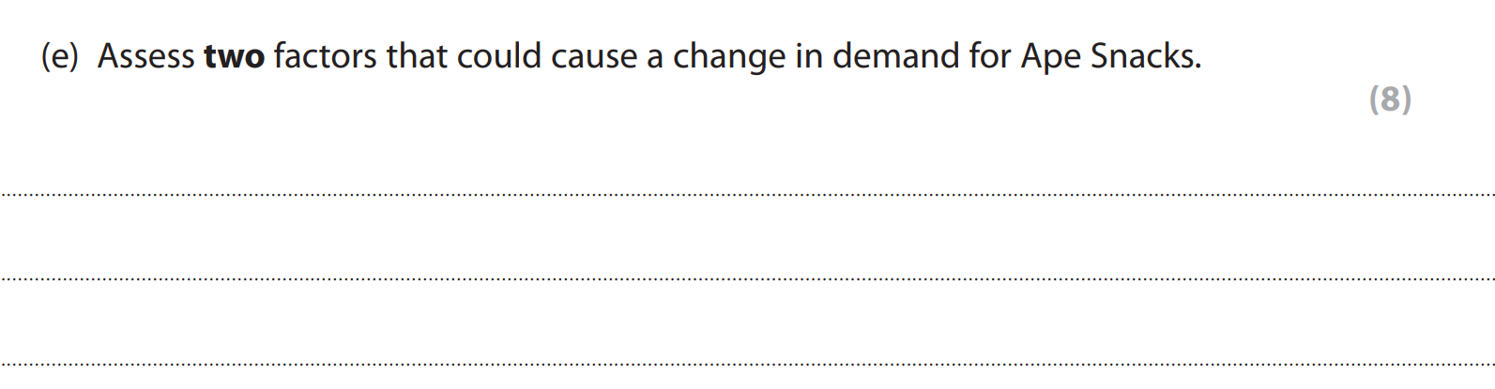

Para 1:
Point: celeb endorsements
Application and analysis: consumers will wish to replicate celebrities’ lifestyles -> increase in demand for coconut based snacks -> increase in demand for Ape Snacks -> more sales -> more profit -> reinvested into advertising -> more demand
However: increase in demand for coconut based snacks does not guarantee an increase in demand for Ape Snacks.
Para 2: environmentally friendly

    - - Markets
Movements
What is equilibrium price?
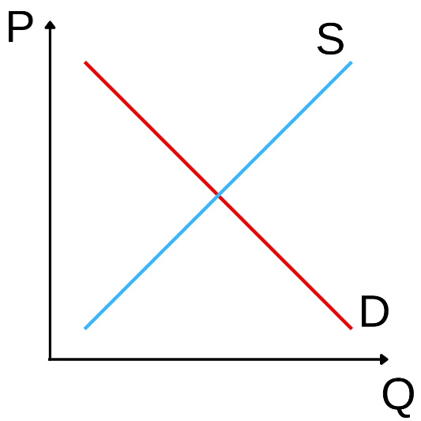
- Equilibrium price is the price charged when the amount demanded is equal to the amount supplied.

What is a surplus?
What is a shortage?

Shifts
What happens to the supply and demand curves when there is:
- A rise in demand?
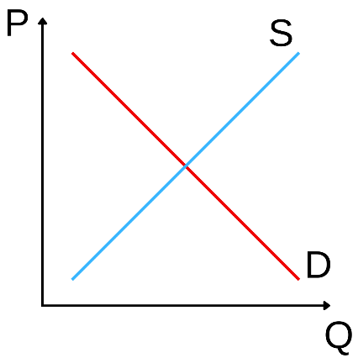

- A fall in demand?

- A rise in supply?

- A fall in supply?



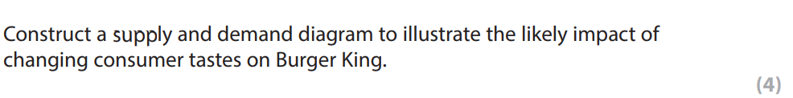

    - - Price elasticity of demand (PED)
What does PED show?
- Shows how level of demand for a product changes with price.

What is the formula for PED?

Calculate PED when a price rise of 20% results in a 30% reduction in demand.

- This product is price elastic, meaning that the % change in demand is greater than the % change in price.
- Price elastic products will have PED of less than -1.

Calculate PED when a price rise of 20% results in a 10% reduction in demand.

- This product is price inelastic, meaning that the % change in demand is less than the % change in price.
- These products are necessities, e.g. petrol, cigarettes.
- Price inelastic products will have PED of between 0 and -1.

Which factors affect price elasticity?
- The availability of substitutes.
- How much of a necessity the product is.
- Brand loyalty.

How might price elasticity of demand affect sales revenue?
- If the product is price elastic, an increase in price will lead to a reduction in revenue.
- If the product is price inelastic, an increase in price will lead to an increase in revenue.

Birdz Ltd sell 100 birdcages per year for £10 each, generating a revenue of £1000.
If PED is -2.5 and Birdz Ltd increases the price by 10%, what is the new sales revenue?
- Revenue = selling price x quantity sold
- Old revenue = 10 x 100 = £1000
- New revenue = 11 x 75 = £825

Price elasticity affects businesses’ pricing strategies. How might a business selling a price elastic product set its prices?
- If the product is price elastic, the business may use a competitive pricing strategy.

Draw demand curves for a price elastic product and a price inelastic product.
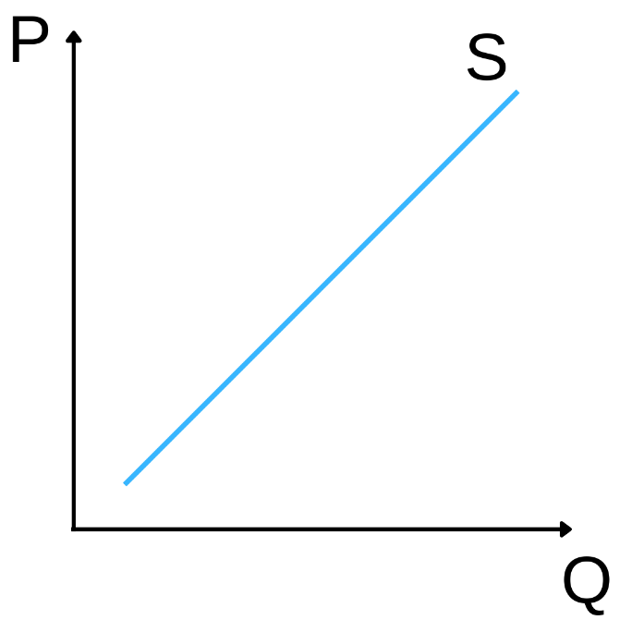

    - - Income elasticity of demand (PED)
What does YED show?
- Tells us how demand for a product changes with consumer income.

What is the formula?

A 20% rise in income results in a 5% increase in demand. Calculate the YED.

- This product is a normal product as YED is a positive number.
- Since YED is between 0 and 1, the product is a necessity.
- If YED is over 1, the product is a luxury.

A 15% fall in income results in a 10% increase in demand. Calculate the YED.

- This product is an inferior good as YED is negative.
- Inferior goods are cheaper versions of products, e.g. supermarket own brand products.

Describe the difference in income elasticity of demand of a normal product (a necessity or luxury) compared with an inferior product.
- If the product is a normal product, it will have a positive YED.
- If the product is an inferior product, it will have a negative YED.

