Theme 2: Topic 1 – Raising Finance
Which factors must a business consider when choosing a source of finance?

2.1.1 - Internal finance
How many internal sources of finance can you list? When would each source be appropriate?

2.1.2 - External finance
How many external sources of finance can you list? When would each source be appropriate?

How many external methods of finance can you list? When would each method be appropriate?

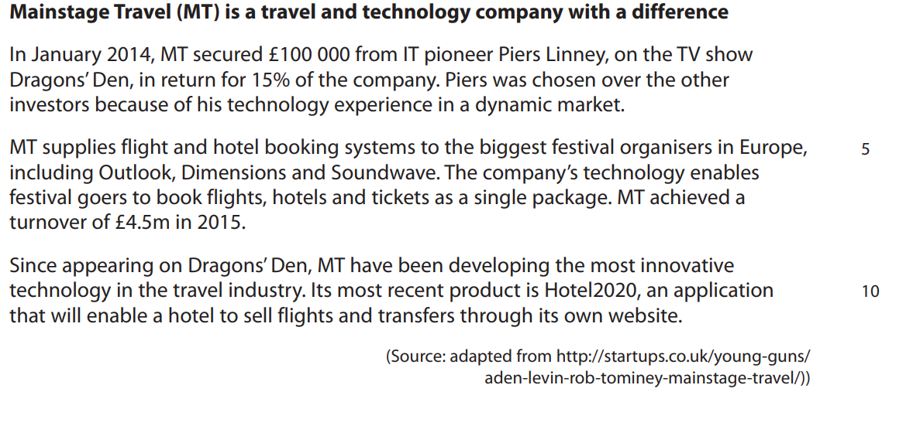

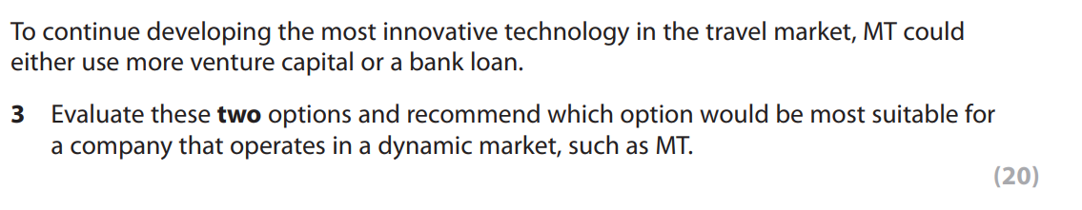

2.1.3 - Liability
What’s the difference between limited liability and unlimited liability?

How does liability affect the sources of finance available to a business?

2.1.4 - Planning
What is a business plan?

How can business plans be used to obtain finance?

What are cash flow forecasts? Why are cash flow forecasts useful?

Are there any limitations to cash flow forecasting?

What is the formula for net cash flow?

Complete the cash flow forecast:

 | Jan | Feb | Mar
Cash inflows
Sales | ? | £5,000 | £4,000
Rent received | £2,000 | £2,000 | £2,000
Total inflows | £10,500 | £7,000 | ?
Cash outflows
Wages | £1,000 | £800 | £700
Raw materials | £1,000 | ? | £500
Advertising | £200 | £200 | £200
Rent | £1,500 | £1,500 | £1,500
Loan repayment | £150 | £150 | £150
Total outflows | £3,850 | £3,450 | ?
Net cash flow | £6,650 | £3,550 | ?
Opening balance | £0 | ? | £10,200
Closing balance | £6,650 | ? | ?

