Theme 3: Topic 3 – Decision-Making Techniques
3.3.1 - Quantitative sales forecasting
Three period moving averages

Table 1
Year | Total Sales (£000) | Three-Year Moving Average (£000)
2015 | 50
2016 | 75
2017 | 55
2018 | 80
2019 | 90

Calculate the three-year moving averages for the sales data in Table 1.

Four-quarter moving averages
Method 1
Table 2
Year and Quarter* | Total Sales (£000) | Four-Quarter Moving Average (£000) | Four-Quarter Moving Average (Trend) (£000)
2021 Q1 | 4
2021 Q2 | 18
2021 Q3 | 22
2021 Q4 | 3
2022 Q1 | 5
2022 Q2 | 25

* Q1 = January-March, Q2 = April-June, Q3 = July-September, Q4 = October-December.

Calculate the four-quarter moving averages for the sales data in Table 2.

***Hint: Method 1 involves firstly calculating the four-quarter moving average by adding up the sales figures for the first FOUR quarters and then dividing by FOUR. Once you have calculated the four-quarter moving averages (you can only work out 3 in total), you then need to work out the four-quarter moving average (trend) figure in the far right column. To do this, you add up the first TWO four quarter moving averages (the ones you just calculated). Then, divide the number you get by TWO. This will give you the four-quarter moving average trend which you can put in the far right column.

Variation
What is cyclical variation and how can it be calculated?

- Using the figures in Table 2, calculate the variation for quarter 3.

- Using the figures in Table 2, calculate the variation for quarter 4.

- How might the variation you calculated in questions (1) and (2) be explained?

What is average variation and how can it be calculated?

Method 2
Table 3
Year and Quarter* | Total Sales (£000) | 8 Period Total | Four-Quarter Moving Average (Trend) (£000)
2021 Q1 | 4
2021 Q2 | 29
2021 Q3 | 32
2021 Q4 | 5
2022 Q1 | 4
2022 Q2 | 35

* Q1 = January-March, Q2 = April-June, Q3 = July-September, Q4 = October-December.

Calculate the four-quarter moving averages for the sales data in Table 3.

***Hint: Method 2 involves firstly calculating the 8 period total. To do this, we must add up the first FOUR sales figures, then shift down a row and add up the next FOUR sales figures. You then add these two numbers together to get the 8 period total. Next, we divide the 8 period total by 8. This gives us the four-quarter moving average.

Extract A
Quarterly sales for CocoIce Ltd 2020-2022
Year and Quarter* | Sales in £’000s | 4 Quarter Total | 8 Period Total | 4 Quarter Moving Average (Trend) | Variation
2020 Q1 | 30
2020 Q2 | 60
 |  | 200
2020 Q3 | 70 |  | 410 | 51.25 | 18.75
 |  | 210
2020 Q4 | 40 |  | 440 | 55 | -15
 |  | 230
2021 Q1 | 40 |  | 460 | 57.5 | -17.5
 |  | 230
2021 Q2 | 80 |  | 470 | 58.75 | 21.25
 |  | 240
2021 Q3 | 70 |  | 480 | 60 | 10
 |  | 240
2021 Q4 | 50 |  | 490 | 61.25 | -11.25
 |  | 250
2022 Q1 | 40 |  | 520 | A | B
 |  | 270
2022 Q2 | 90 |  | 550 | C | D
 |  | 280
2022 Q3 | 90
2022 Q4 | 60

* Q1 = January-March, Q2 = April-June, Q3 = July-September, Q4 = October-December.

Extract B
CocoIce Ltd potential expansion
CocoIce Ltd is a premium ice cream brand that was founded by Louise Bridge and Emma Bailey after they graduated from university in 2013. They have 10 ice cream parlours located mostly in town centres, as well as operating over 100 ice cream vans in beach locations.
CocoIce serve luxury flavours of ice cream in coconut shells, making the product highly ‘Instagram-able’. Many customers take photos of their ice cream and post them on social media. This allows CocoIce to keep its marketing costs down as awareness is spread organically through social media and word of mouth.
Louise and Emma are now considering expanding to Australia. There is year-round sunshine in Australia, and it is located in the Southern Hemisphere meaning that the summer months are December, January and February while the winter months are June, July and August.

CocoIce Ltd is deciding whether to expand their existing UK operations or to set up new outlets in Australia.
Using the data in Extract A, calculate the values of A, B, C and D and, using the non-financial information in Extract B, evaluate these two options.
Recommend which one of these two options CocoIce should choose in order to grow.
(20)

Scatter graphs
Why might a business find it useful to plot sales data on a scatter graph?

What is a line of best fit?

Extrapolation
What is extrapolation?

What are the pros and cons of extrapolation?

Table 4: Quarterly sales for CocoIce Ltd 2018-2022
Year | Quarter | Sales in £’000s | 4 Quarter Moving Average (Trend) | Variation | Average Variation
2018 | 1 | 30
2018 | 2 | 60
2018 | 3 | 60 | 46.25 | 13.75 | 15.94
2018 | 4 | 40 | 45 | -5 | -10.31
2019 | 1 | 20 | 46.25 | -26.25 | -22.19
2019 | 2 | 60 | 47.50 | 12.50 | B
2019 | 3 | 70 | 48.75 | 21.25 | 15.94
2019 | 4 | 40 | 50 | -10 | -10.31
2020 | 1 | 30 | 50 | -20 | -22.19
2020 | 2 | 60 | 50 | 10 | B
2020 | 3 | 70 | 51.25 | 18.75 | 15.94
2020 | 4 | 40 | 55 | -15 | -10.31
2021 | 1 | 40 | 57.5 | -17.5 | -22.19
2021 | 2 | 80 | 58.75 | 21.25 | B
2021 | 3 | 70 | 60 | 10 | 15.94
2021 | 4 | 50 | 61.25 | -11.25 | -10.31
2022 | 1 | 40 | 65 | A | -22.19
2022 | 2 | 90 | 68.75 | 21.25 | B
2022 | 3 | 90
2022 | 4 | 60

Using Table 4, calculate:
- the seasonal variation in 2022 quarter 1 (labelled A above).

- average variation in quarter 2.

Graph of sales data over time and line of best fit
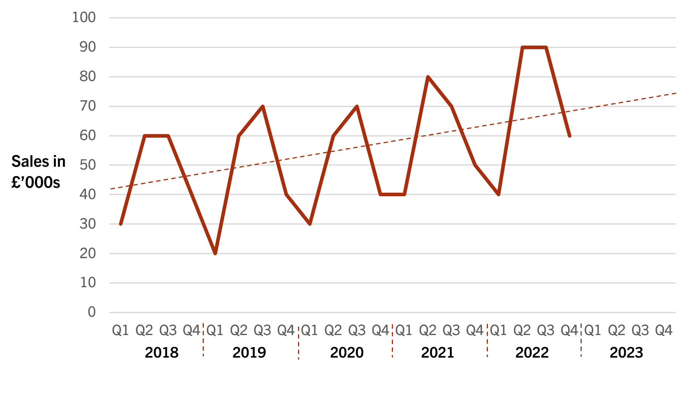
Using the average variation from Table 4 and the line of best fit in the graph above, calculate CocoIce’s forecast sales for 2023 Q3.

3.3.2 - Investment appraisal
Average Rate of Return (ARR)
What does the average rate of return show?

What is the formula for average rate of return?

A business is considering two projects, but only has the resources to carry out one of the proposed projects.
Project A involves launching a new version of their product. Project B is an investment into a new advertising campaign.

 | Investment | Year 1 | Year 2 | Year 3 | Year 4 | Year 5
Project A | (£15,000) | £4,000 | £6,000 | £7,000 | £6,000 | £7,000
Project B | (£20,000) | £5,000 | £5,000 | £5,000 | £8,000 | £4,000

Which investment has a higher ARR?

Payback
What is meant by ‘payback period’?

Calculate the payback period of a £100k project that has an annual net return prediction of £20k?

The following information is being used to help Heinz Electricals perform an investment appraisal of their decision to buy the lease of a new store in Manchester.

Table 1
Year | Net Cash Flow (£000)
0 | (500)
1 | 100
2 | 200
3 | 300
4 | 350
5 | 400

Using the data in Table 1, calculate the payback period and the average rate of return.
(4)

Can you think of any limitations of using ARR and payback to assess investments?

Net Present Value (NPV)
What is discounting?

Investment: £1000

 | Net Cash Flow | Discount Factor | Present Value
Year 1 | £200 | 0.95
Year 2 | £300 | 0.92
Year 3 | £500 | 0.87
Year 4 | £600 | 0.85
Year 5 | £600 | 0.83

Calculate NPV.

3.3.3 - Decision trees
What’s the difference between the expected monetary value (EMV) of a decision and the net gain of a decision?

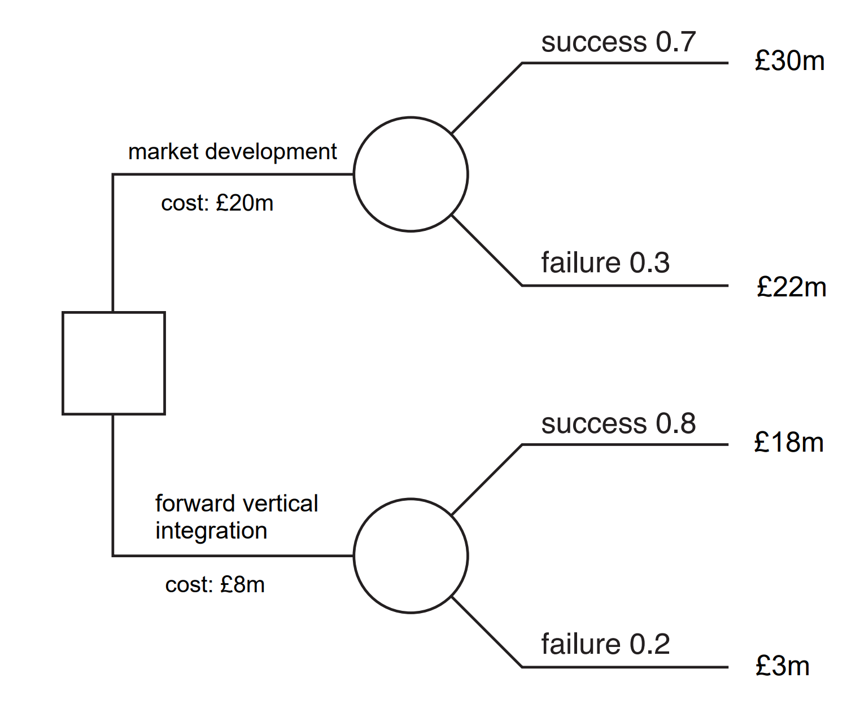

Which decision is the most worthwhile?

Can you think of any advantages and disadvantages of decision tree analysis?

Which non-numerical, qualitative factors might also influence business decisions?

3.3.4 - Critical path analysis
Zelda Industries has constructed the network diagram below to plan the development and launch of a new product. Each number represents how many days each activity is estimated to take.

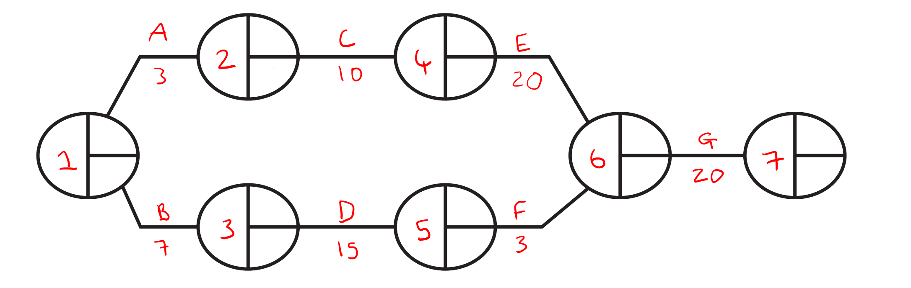

Activity A: Recruit new staff
Activity B: Market research
Activity C: Train staff
Activity D: Create a marketing plan
Activity E: Create new product
Activity F: Analyse marketing plan
Activity G: Product trials

- Using the data in the network diagram above, calculate the Earliest Start Times (EST) and the Latest Finishing Times (LFT) for each activity and identify the critical path.

- Calculate the total float time of Activity F.

What is a dummy activity?

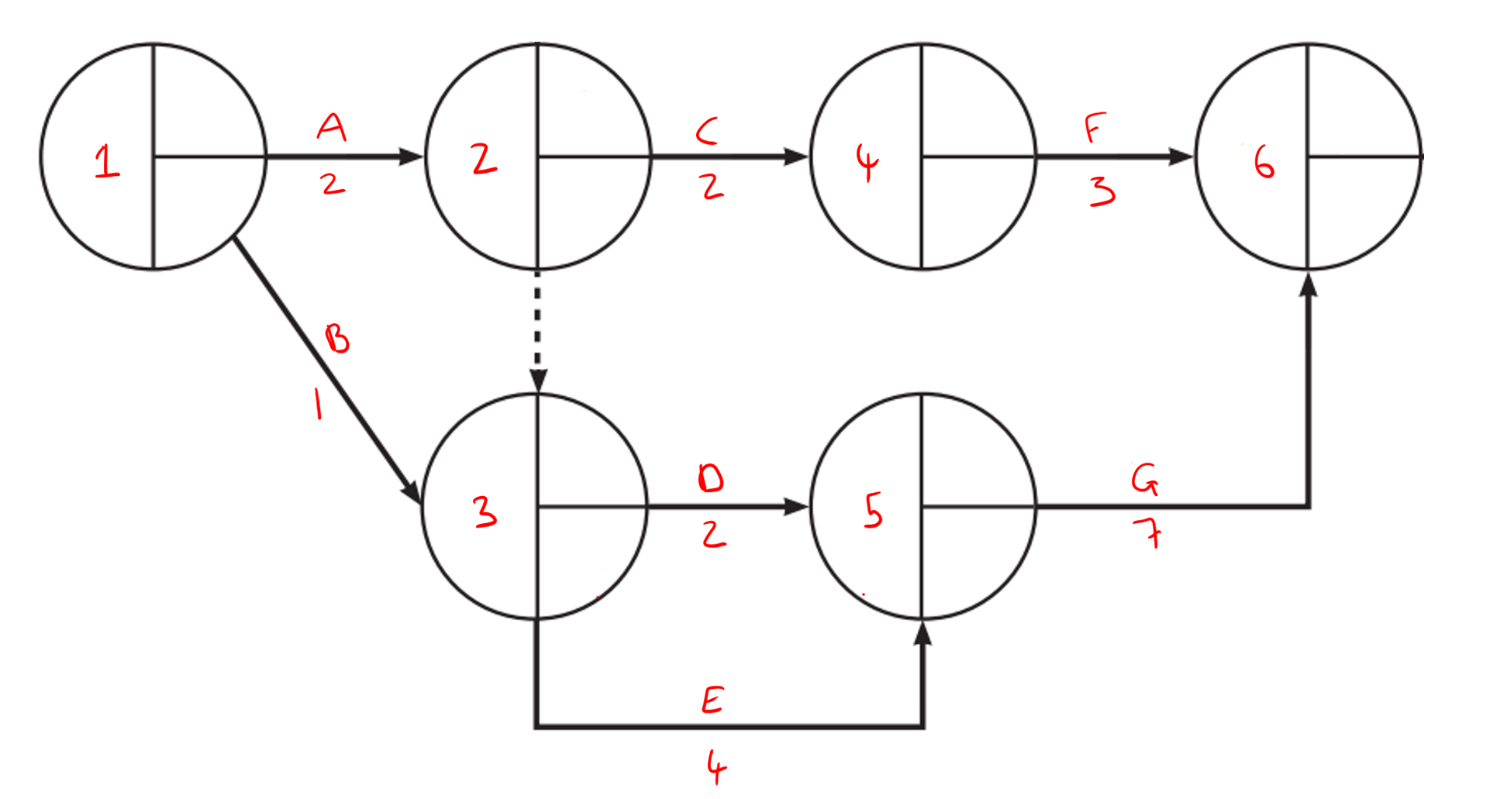

- Complete the network diagram.

- State the activities on the critical path.

Can you think of any benefits or limitations of critical path analysis?

Extract A
Office furniture
Zelda Industries is a leading manufacturer of office furniture. The company has an expansive product range due to its market orientation and invests heavily in research and development.
The market is highly competitive, but Zelda is able to stay ahead by responding very quickly to the needs of its customers.

Extract B
Zelda Industries product launch
Zelda Industries has constructed the network diagram below to plan the development and launch of a new product. Each number represents how many days each activity is estimated to take.

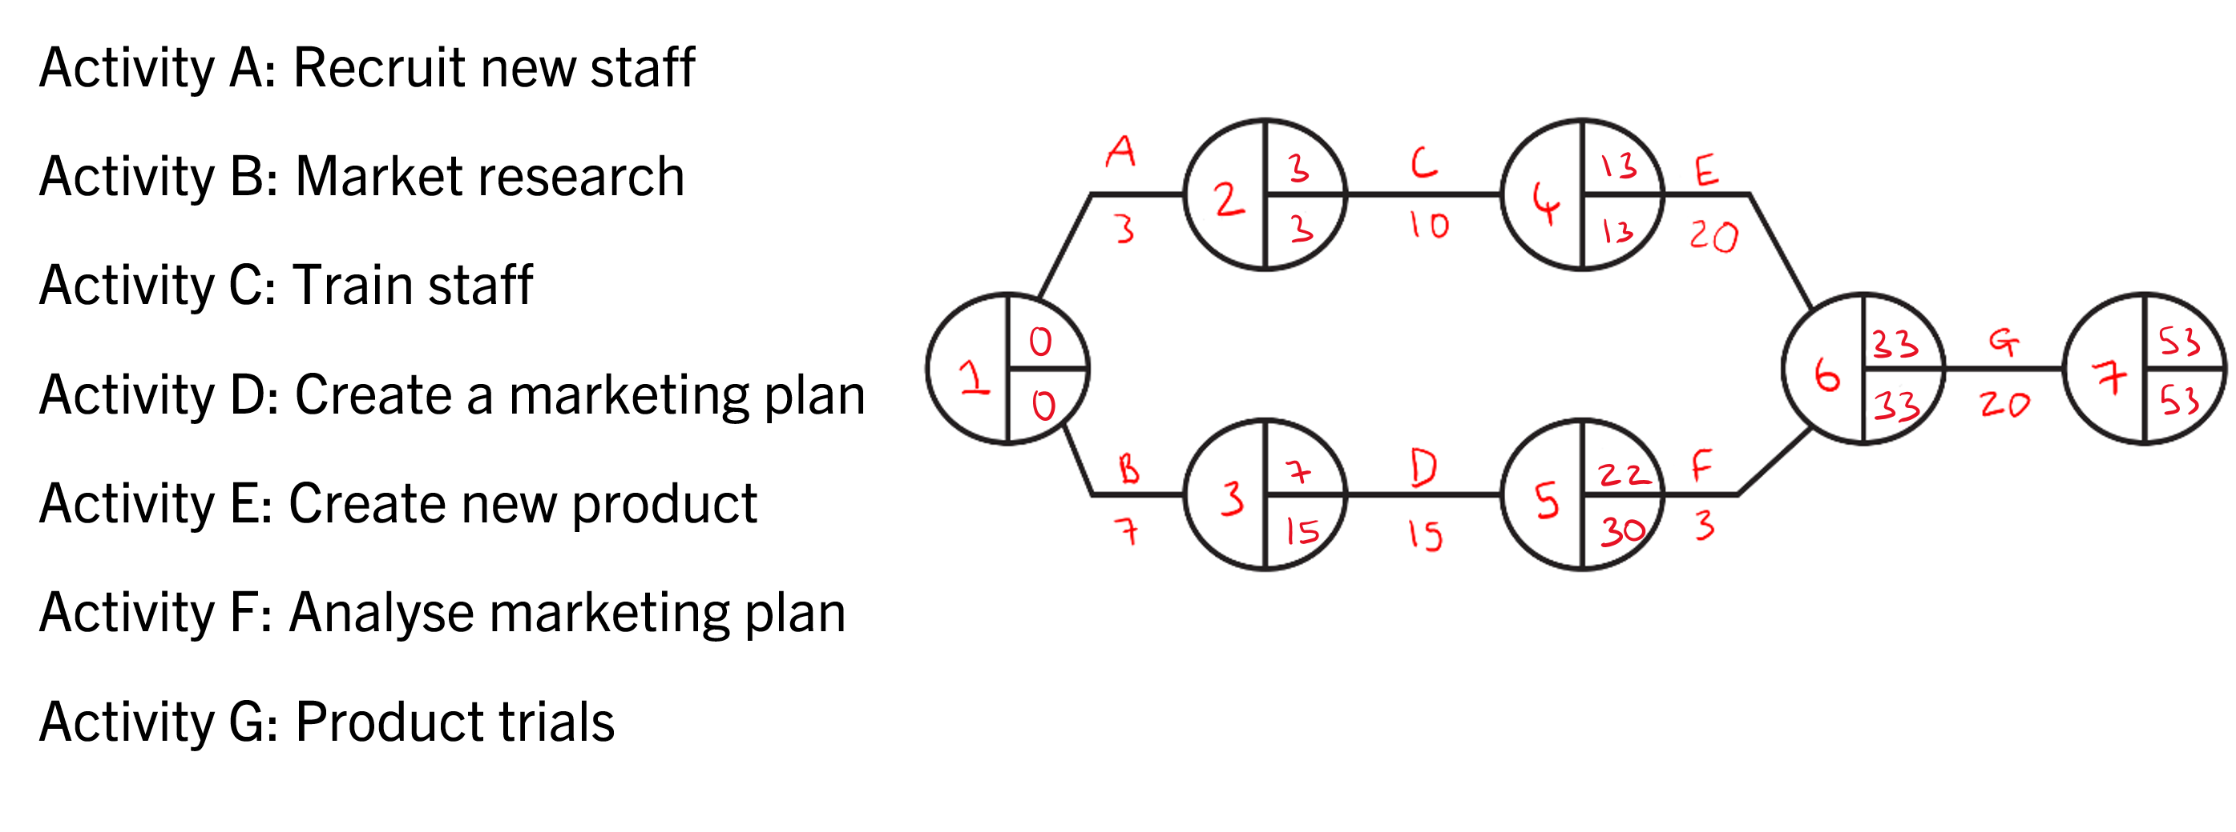

Assess the likely value of Critical Path Analysis (CPA) for the effective management of the new product launch.
(10)

