Theme 3: Topic 3 – Decision-Making Techniques
3.3.1 - Quantitative sales forecasting
Three period moving averages

Table 1
Year | Total Sales (£000) | Three-Year Moving Average (£000)
2015 | 50
2016 | 75
2017 | 55
2018 | 80
2019 | 90

Calculate the three-year moving averages for the sales data in Table 1.

Four-quarter moving averages
Method 1
Table 2
Year and Quarter* | Total Sales (£000) | Four-Quarter Moving Average (£000) | Four-Quarter Moving Average (Trend) (£000)
2021 Q1 | 4
2021 Q2 | 18
2021 Q3 | 22
2021 Q4 | 3
2022 Q1 | 5
2022 Q2 | 25

* Q1 = January-March, Q2 = April-June, Q3 = July-September, Q4 = October-December.

Calculate the four-quarter moving averages for the sales data in Table 2.

***Hint: Method 1 involves firstly calculating the four-quarter moving average by adding up the sales figures for the first FOUR quarters and then dividing by FOUR. Once you have calculated the four-quarter moving averages (you can only work out 3 in total), you then need to work out the four-quarter moving average (trend) figure in the far right column. To do this, you add up the first TWO four quarter moving averages (the ones you just calculated). Then, divide the number you get by TWO. This will give you the four-quarter moving average trend which you can put in the far right column.

Variation
What is cyclical variation and how can it be calculated?
- cyclical variation refers to how sales fluctuate within a given cycle
- cyclical variation = actual sales figure – moving average

- Using the figures in Table 2, calculate the variation for quarter 3.
- variation = 22,000 – 11,875 = £10,125

- Using the figures in Table 2, calculate the variation for quarter 4.
- variation = 3,000 – 12,875 = - £9,875

- How might the variation you calculated in questions (1) and (2) be explained?
- it is likely to be a seasonal business that sells products that are popular during the summer months.

What is average variation and how can it be calculated?
- average variation = the variation for a certain quarter added up then divided by the number of quarters you have added.

Method 2
Table 3
Year and Quarter* | Total Sales (£000) | 8 Period Total | Four-Quarter Moving Average (Trend) (£000)
2021 Q1 | 4
2021 Q2 | 29
2021 Q3 | 32
2021 Q4 | 5
2022 Q1 | 4
2022 Q2 | 35

* Q1 = January-March, Q2 = April-June, Q3 = July-September, Q4 = October-December.

Calculate the four-quarter moving averages for the sales data in Table 3.

***Hint: Method 2 involves firstly calculating the 8 period total. To do this, we must add up the first FOUR sales figures, then shift down a row and add up the next FOUR sales figures. You then add these two numbers together to get the 8 period total. Next, we divide the 8 period total by 8. This gives us the four-quarter moving average.

Extract A
Quarterly sales for CocoIce Ltd 2020-2022
Year and Quarter* | Sales in £’000s | 4 Quarter Total | 8 Period Total | 4 Quarter Moving Average (Trend) | Variation
2020 Q1 | 30
2020 Q2 | 60
 |  | 200
2020 Q3 | 70 |  | 410 | 51.25 | 18.75
 |  | 210
2020 Q4 | 40 |  | 440 | 55 | -15
 |  | 230
2021 Q1 | 40 |  | 460 | 57.5 | -17.5
 |  | 230
2021 Q2 | 80 |  | 470 | 58.75 | 21.25
 |  | 240
2021 Q3 | 70 |  | 480 | 60 | 10
 |  | 240
2021 Q4 | 50 |  | 490 | 61.25 | -11.25
 |  | 250
2022 Q1 | 40 |  | 520 | A | B
 |  | 270
2022 Q2 | 90 |  | 550 | C | D
 |  | 280
2022 Q3 | 90
2022 Q4 | 60

* Q1 = January-March, Q2 = April-June, Q3 = July-September, Q4 = October-December.

Extract B
CocoIce Ltd potential expansion
CocoIce Ltd is a premium ice cream brand that was founded by Louise Bridge and Emma Bailey after they graduated from university in 2013. They have 10 ice cream parlours located mostly in town centres, as well as operating over 100 ice cream vans in beach locations.
CocoIce serve luxury flavours of ice cream in coconut shells, making the product highly ‘Instagram-able’. Many customers take photos of their ice cream and post them on social media. This allows CocoIce to keep its marketing costs down as brand awareness is spread organically through social media and word of mouth.
Louise and Emma are now considering expanding to Australia. Australia has year-round sunshine and is located in the Southern Hemisphere, meaning that the summer months are December, January and February while the winter months are June, July and August.

CocoIce Ltd is deciding whether to expand their existing UK operations or to set up new outlets in Australia.
Using the data in Extract A, calculate the values of A, B, C and D and, using the non-financial information in Extract B, evaluate these two options.
Recommend which one of these two options CocoIce should choose in order to grow.
(20)
A = £65,000, B = - £25,000, C = £68,750, D = £21,250
- PARA 1: pro of Australian expansion
  - Point: sales are lower during the UK winter time so expanding to Australia would reduce the fluctuations in the sales as CocoIce could make up for the shortfall during winter
  - Application: use figures calculated (A, B, C and D)
  - Analysis: this would mean that CocoIce has better cash flow -> easier to pay the bills on time, e.g. rent on the ice cream parlours -> maintain a good credit rating -> easier to persuade sources of finance, e.g. the bank or investors which would be particularly important for CocoIce as they would need additional finance to fund the Australian expansion -> access a new market + new customers -> more sales -> higher revenue -> growth
- PARA 2: con of Australian expansion
  - Point: market development is riskier than market penetration according to Ansoff’s Matrix
  - Application: Australia is an unfamiliar market so there could be unforeseen differences between the UK and Australian market, e.g. Australians may not use social media in the same way which would be particularly consequential for CocoIce as most of their brand awareness has been spread through social media
  - Analysis: CocoIce would have to invest in other forms of promotion such as celebrity endorsement -> less to spend on setting up the outlets -> slower expansion -> slower growth
  - Evaluation: pro outweighs the con as it would allow CocoIce to increase sales during winter which is currently the time they are struggling to increase sales. Any potential risks could be mitigated by carrying out market research.
- PARA 3: pro of expanding their existing operations
  - Point: already successful and have found a business model that works in the UK
  - Application:
  - Analysis:
- PARA 4: con of expanding existing operations
  - Point: slower growth
  - Application:
  - Analysis:
- AJIM Conclusion
  - Answer the question: should expand to Australia
  - Justify your answer: new market of customers to access -> faster growth
  - It depends on whether they can finance the expansion out of their retained profit or raising venture capital.
  - Most important factor

Scatter graphs
Why might a business find it useful to plot sales data on a scatter graph?
- Can spot trends in the data and then plan ahead, e.g. buy enough supplies or hire new employees.

What is a line of best fit?

Extrapolation
What is extrapolation?

What are the pros and cons of extrapolation?
- Pro: easy way to predict future sales.
- Con: past trends are no guarantee of the future, e.g. future sales may be impacted by changing consumer tastes and external shocks.

Table 4: Quarterly sales for CocoIce Ltd 2018-2022
Year | Quarter | Sales in £’000s | 4 Quarter Moving Average (Trend) | Variation | Average Variation
2018 | 1 | 30
2018 | 2 | 60
2018 | 3 | 60 | 46.25 | 13.75 | 15.94
2018 | 4 | 40 | 45 | -5 | -10.31
2019 | 1 | 20 | 46.25 | -26.25 | -22.19
2019 | 2 | 60 | 47.50 | 12.50 | B
2019 | 3 | 70 | 48.75 | 21.25 | 15.94
2019 | 4 | 40 | 50 | -10 | -10.31
2020 | 1 | 30 | 50 | -20 | -22.19
2020 | 2 | 60 | 50 | 10 | B
2020 | 3 | 70 | 51.25 | 18.75 | 15.94
2020 | 4 | 40 | 55 | -15 | -10.31
2021 | 1 | 40 | 57.5 | -17.5 | -22.19
2021 | 2 | 80 | 58.75 | 21.25 | B
2021 | 3 | 70 | 60 | 10 | 15.94
2021 | 4 | 50 | 61.25 | -11.25 | -10.31
2022 | 1 | 40 | 65 | A | -22.19
2022 | 2 | 90 | 68.75 | 21.25 | B
2022 | 3 | 90
2022 | 4 | 60

Using Table 4, calculate:
- the seasonal variation in 2022 quarter 1 (labelled A above).
- seasonal variation = actual sales figure – 4-quarter moving average (trend)
- season variation = 40 – 65 = -25

- average variation in quarter 2.
average variation = 12.5 + 10 + 21.25 + 21.25 / 4 = 16.25

Graph of sales data over time and line of best fit
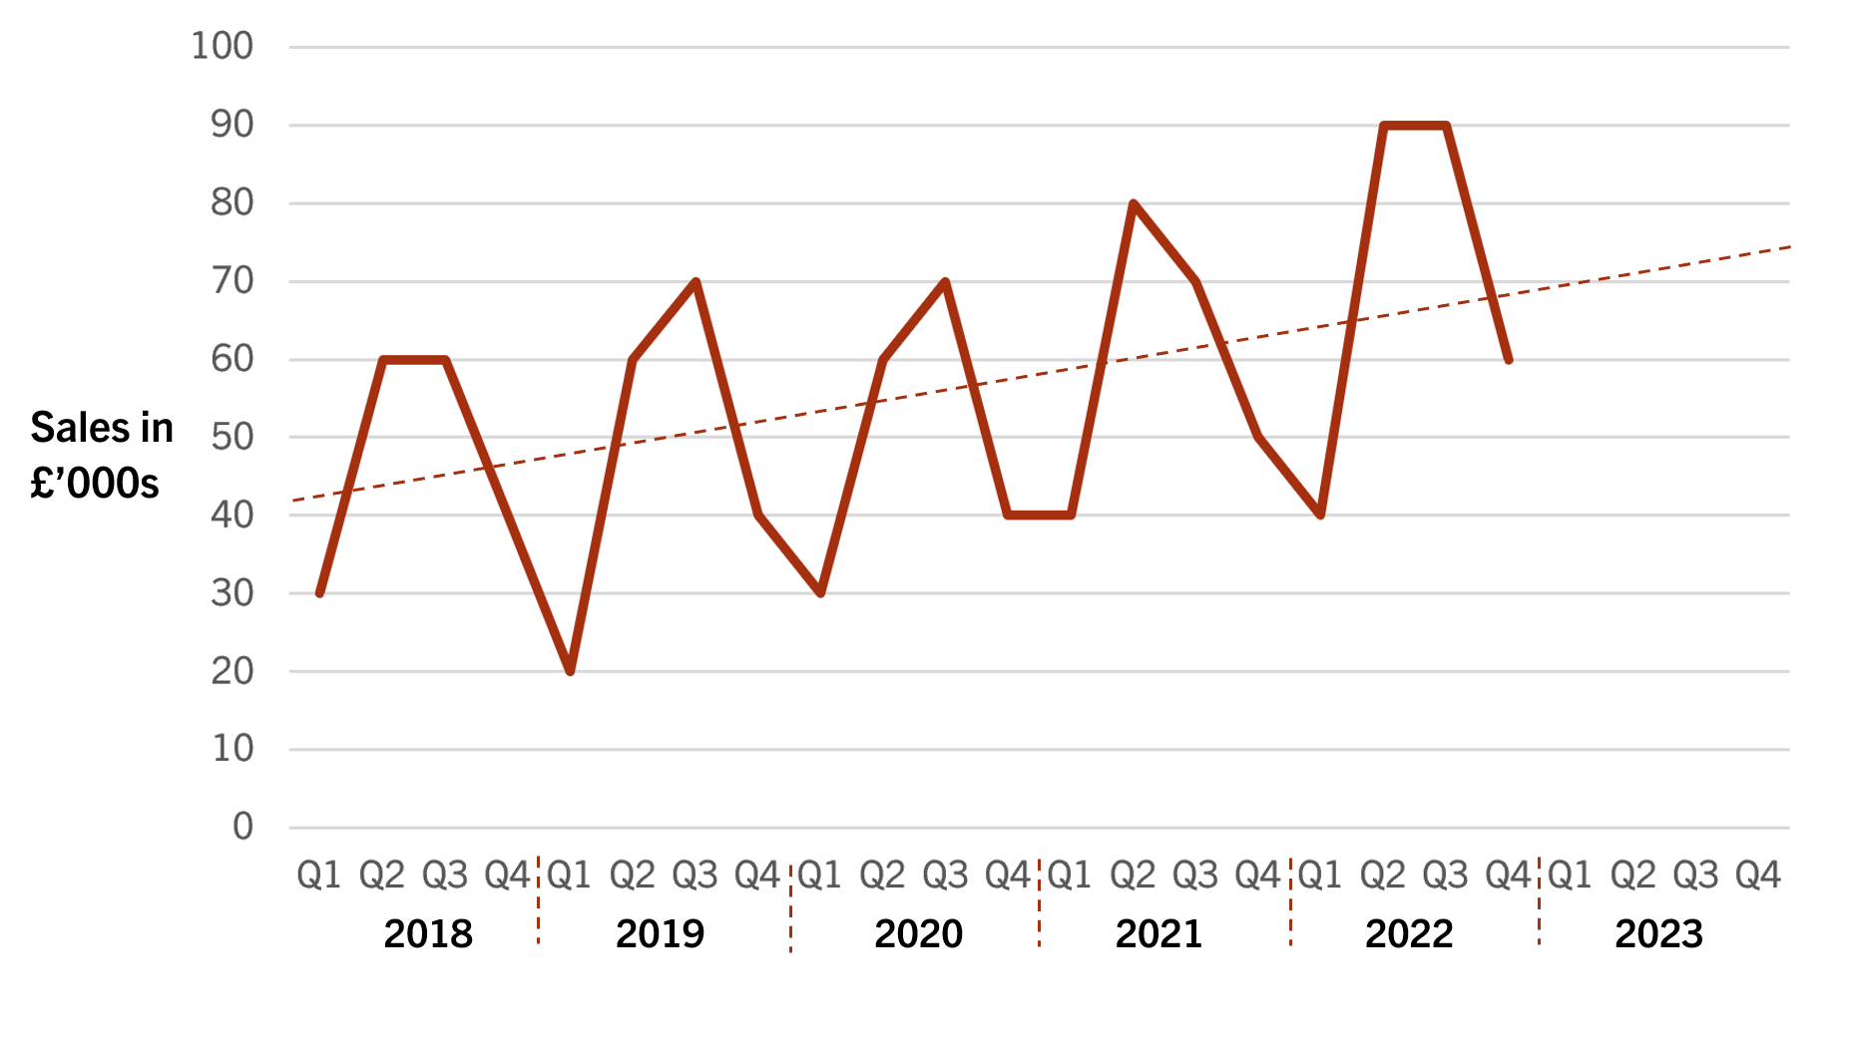
Using the average variation from Table 4 and the line of best fit in the graph above, calculate CocoIce’s forecast sales for 2023 Q3.
73,000 + 15,940 = £88,940

3.3.2 - Investment appraisal
Average Rate of Return (ARR)
What does the average rate of return show?
- Compares the average annual net return with the initial investment.

What is the formula for average rate of return?

A business is considering two projects, but only has the resources to carry out one of the proposed projects.
Project A involves launching a new version of their product. Project B is an investment into a new advertising campaign.

 | Investment | Year 1 | Year 2 | Year 3 | Year 4 | Year 5
Project A | (£15,000) | £4,000 | £6,000 | £7,000 | £6,000 | £7,000
Project B | (£20,000) | £5,000 | £5,000 | £5,000 | £8,000 | £4,000

Which investment has a higher ARR?

Payback
What is meant by ‘payback period’?
- How it takes the business to get their money back from an investment.

Calculate the payback period of a £100k project that has an annual net return prediction of £20k?

The following information is being used to help Heinz Electricals perform an investment appraisal of their decision to buy the lease of a new store in Manchester.

Table 1
Year | Net Cash Flow (£000)
0 | (500)
1 | 100
2 | 200
3 | 300
4 | 350
5 | 400

Using the data in Table 1, calculate the payback period and the average rate of return.
(4)

Can you think of any limitations of using ARR and payback to assess investments?
- Ignores the timings of the cash flows.
- Ignores the ‘time value of money’

Net Present Value (NPV)
What is discounting?
- The process of adjusting the cash flows to reflect their present value.

Investment: £1000

 | Net Cash Flow | Discount Factor | Present Value
Year 1 | £200 | 0.95 | £190
Year 2 | £300 | 0.92 | £276
Year 3 | £500 | 0.87 | £435
Year 4 | £600 | 0.85 | £510
Year 5 | £600 | 0.83 | £498

Calculate NPV.
Total present value = 190 + 276 + 435 + 510 + 498 = £1909
Net present value = total present value – initial investment
Net present value = £1909 – £1000 = £909

3.3.3 - Decision trees
What’s the difference between the expected monetary value (EMV) of a decision and the net gain of a decision?
- The EMV of a particular outcome is the probability multiplied by the expected pay off. The EMV of a particular decision would be the EMVs of the different outcomes added up.
- The net gain is the EMV minus the initial cost.

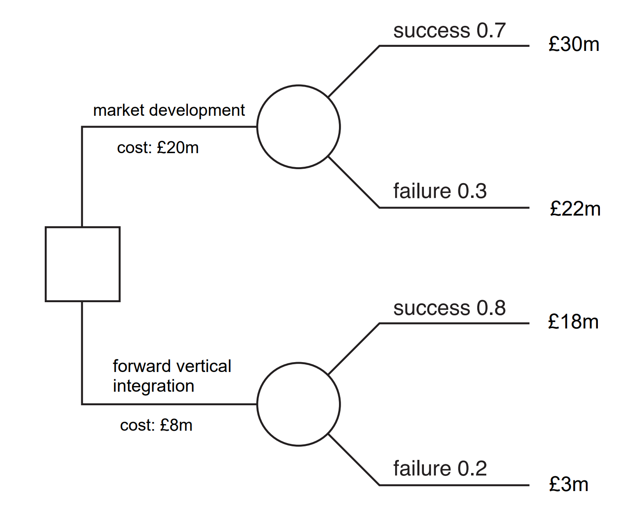

Which decision is the most worthwhile?

- The market development strategy is more worthwhile.

Can you think of any advantages and disadvantages of decision tree analysis?
- Pros:
  - Good visual aid.
  - Forces managers to think quantitatively about the potential decisions.
  - Makes it easier for managers to justify decisions.
- Cons:
  - The probabilities and expected pay-offs are estimates and may not be accurate.
  - There will other potential outcomes that are not considered.
  - External influences could affect the probabilities.
  - The decision tree may be biased if the person making it has a preference for a particular outcome.

Which non-numerical, qualitative factors might also influence business decisions?
- Reputation of the business.
- Mission statement of the business.
- Corporate objectives.
- Employees’ opinions.
- Customers’ opinions.

3.3.4 - Critical path analysis
Zelda Industries has constructed the network diagram below to plan the development and launch of a new product. Each number represents how many days each activity is estimated to take.

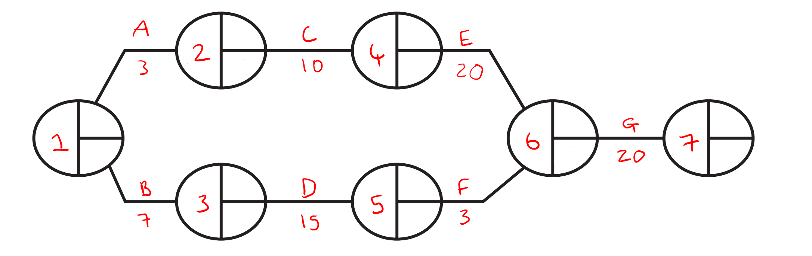

Activity A: Recruit new staff
Activity B: Market research
Activity C: Train staff
Activity D: Create a marketing plan
Activity E: Create new product
Activity F: Analyse marketing plan
Activity G: Product trials

- Using the data in the network diagram above, calculate the Earliest Start Times (EST) and the Latest Finishing Times (LFT) for each activity and identify the critical path.

- Calculate the total float time of Activity F.
Total float = LFT – duration – EST
Total float = 33 – 3 – 22 = 8 days
This means that activity F can be delayed by up to 8 days without delaying the entire project.
What is a dummy activity?
- An imaginary activity that shows in which order the activities must take place. E.g., looking at the network diagram below, A and B must take place before D and E. If the dummy activity (dotted line) wasn’t there, then we wouldn’t have to do A before D and E.
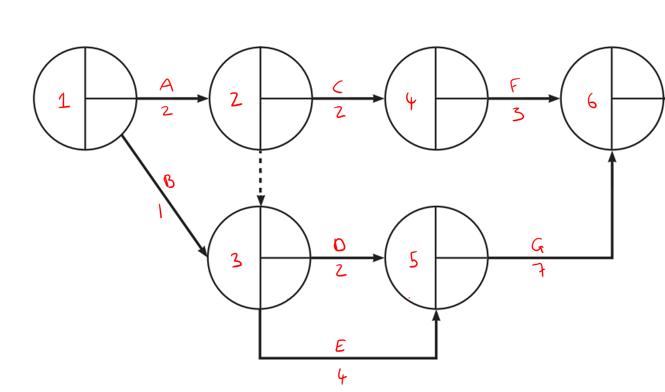

- Complete the network diagram.

- State the activities on the critical path.

- A, E, G.

Can you think of any benefits or limitations of critical path analysis?
- Pros:
  - Allows the business to identify the critical activities.
  - The business can transfer resources from activities with float time to the critical activities.
  - Good visual aid.
  - Forces managers to think about how long each activity will take.
  - Allows the project to be finished sooner as activities are done in the most efficient order.
- Cons:
  - Durations are estimates which could be inaccurate.
  - Strict deadlines may mean that the quality suffers as employees will rush.
  - Doesn’t take into account unforeseen circumstances such as covid-19.

Extract A
Office furniture
Zelda Industries is a leading manufacturer of office furniture. The company has an expansive product range due to its market orientation and invests heavily in research and development.
The market is highly competitive, but Zelda is able to stay ahead by responding very quickly to the needs of its customers.

Extract B
Zelda Industries product launch
Zelda Industries has constructed the network diagram below to plan the development and launch of a new product. Each number represents how many days each activity is estimated to take.

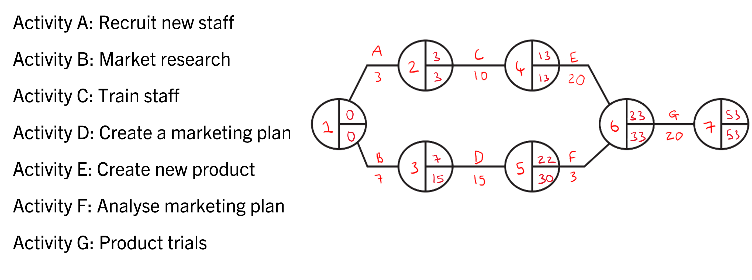

Assess the likely value of Critical Path Analysis (CPA) for the effective management of the new product launch.
(10)

Para 1: reason why it is useful
- Point and application: can identify activities with float time (B, D, F) and then divert resources from those activities to the ones on the critical path (A, C, E)
- Analysis: this would be particularly important for Zelda as it would ensure the project is completed on time and they can get their product to the market quickly which is how they stay ahead of competitors -> increase market share -> more power in the market -> can negotiate cheaper prices with suppliers -> higher profit margins -> more capital to invest into extending the product range further.
Para 2: counterargument
- Point: predictions may not be accurate meaning employees have to rush to complete the project on time
- Application: for example, training the staff effectively may take longer than 10 days
- Analysis: may not be trained properly -> aren’t capable of developing the best product (activity E) -> fewer sales -> lower revenue -> lower return on investment
AJIM conclusion
Answer the question: it is valuable
Justify: it gives Zelda a clear deadline and allows them to identify the critical activities and the drawback that it is based on predictions which may be inaccurate could be mitigated by spending more time researching the project.
It depends on: whether any external shocks take place that delay the project and make the CPA redundant.
Most important factor

